MIN HO KIM

Professor Kalathas

CS 261

3 November 2022

**Assignment 4 Questions**

1. **Show the binary search tree built by adding numbers in this specific order, assuming the tree is empty to start with: 50, 16, 90, 14, 32, 71, 42, 5 (You may need to add more boxes to the diagram).**

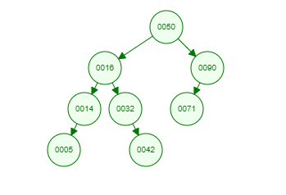

1. **The trouble with binary search trees is that they can become unbalanced depending on the order that you insert values. Give an order for inserting the numbers 3, 4, 5, 6, 7, 8, 9, 10, 11, 12, 13 such that the resulting tree is a complete binary search tree. Please make that your intermediate trees are also complete binary search trees as well. (Hint: it might be helpful to first draw the full/complete tree to figure out how the values must be arranged, then you can determine the order to add them.)**

10, 6, 12, 4, 8, 11, 13, 3, 5, 7, 9

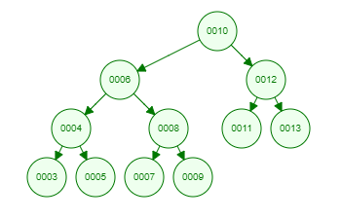

1. **Part A: Given the following tree, question3.pdf, show the tree after removing the value 40. Part B: Using the tree produced by Part A, show the tree after removing the value 16.**

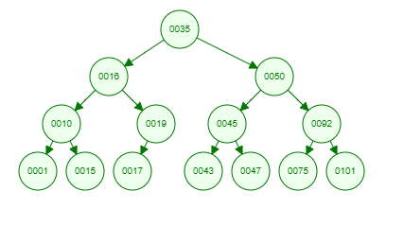

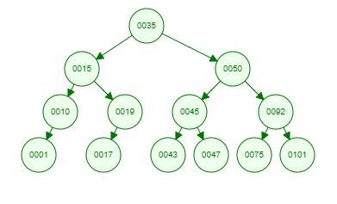

1. **The computer has built the following decision tree for the Guess the Animal Game, question4.pdf. The player has an animal in mind and will answer the questions shown in the tree. Each of the players responses is used to determine the next question to ask. For example, if the player is thinking of a sea turtle, she would answer Yes to the first (top) question, "does it live in the water?", which leads to the second question "is it a mammal?", to which she would answer No. Show the decision tree that the computer should build after adding a Dragon and a question to differentiate it, "Can it spit fire?", to the tree. The question and the animal should be added below existing questions in the tree. Note that Dragons do spit fire, but do not live in the water, do not climb trees, and they are not mammals.**

